FURTHER EDUCATION AND TRAINING CERTIFICATE: INFORMATION TECHNOLOGY: SYSTEMS DEVELOPMENT
ID 78965 LEVEL 4 – CREDITS 165
LEARNER GUIDE
SAQA:- 119472
ACCOMMODATE AUDIENCE AND CONTEXT NEEDS IN ORAL/SIGNED COMMUNICATION



Learner Information:
Details | Please Complete this Section
Name & Surname:
Organisation:
Unit/Dept:
Facilitator Name:
Date Started:
Date of Completion:

Copyright
All rights reserved. The copyright of this document, its previous editions and any annexures thereto, is protected and expressly reserved. No part of this document may be reproduced, stored in a retrievable system, or transmitted, in any form or by any means, electronic, mechanical, photocopying, recording or otherwise without the prior permission.

Key to Icons
The following icons may be used in this Learner Guide to indicate specific functions:
  Books | This icon means that other books are available for further information on a particular topic/subject.
  References | This icon refers to any examples, handouts, checklists, etc…
  Important | This icon represents important information related to a specific topic or section of the guide.
  Activities | This icon helps you to be prepared for the learning to follow or assist you to demonstrate understanding of module content. Shows transference of knowledge and skill.
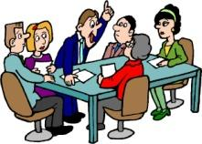  Exercises | This icon represents any exercise to be completed on a specific topic at home by you or in a group.
  Tasks/Projects | An important aspect of the assessment process is proof of competence. This can be achieved by observation or a portfolio of evidence should be submitted in this regard.
  Workplace Activities | An important aspect of learning is through workplace experience. Activities with this icon can only be completed once a learner is in the workplace
  Tips | This icon indicates practical tips you can adopt in the future.
  Notes | This icon represents important notes you must remember as part of the learning process.

Learner Guide Introduction

About the Learner Guide… | This Learner Guide provides a comprehensive overview of the Accommodate audience and context needs in oral/signed communication texts and forms part of a series of Learner Guides that have been developed for  The series of Learner Guides are conceptualized in modular’s format and developed for  They are designed to improve the skills and knowledge of learners, and thus enabling them to effectively and efficiently complete specific tasks.  Learners are required to attend training workshops as a group or as specified by their organization. These workshops are presented in modules, and conducted by a qualified facilitator.
Purpose | A learner achieving this unit standard should be able to demonstrate basic understanding Accommodate audience and context needs in oral/signed communication texts
Outcomes | At the end of this module, you will be able to:  - Interact successfully in oral/signed communication  - Use strategies that capture and retain the interest of an audience  - Identify and respond to manipulative use of language
Assessment Criteria | The only way to establish whether a learner is competent and has accomplished the specific outcomes is through an assessment process.  Assessment involves collecting and interpreting evidence about the learner’s ability to perform a task.  This guide may include assessments in the form of activities, assignments, tasks or projects, as well as workplace practical tasks. Learners are required to perform tasks on the job to collect enough and appropriate evidence for their portfolio of evidence, proof signed by their supervisor that the tasks were performed successfully.
To qualify | To qualify and receive credits towards the learning programme, a registered assessor will conduct an evaluation and assessment of the learner’s portfolio of evidence and competency
Range of Learning | This describes the situation and circumstance in which competence must be demonstrated and the parameters in which learners operate
Responsibility | The responsibility of learning rest with the learner, so:  - Be proactive and ask questions,  - Seek assistance and help from your facilitators, if required.

Learning Unit1
Accommodate audience and context needs in oral/signed communication texts
UNIT STANDARD NUMBER : 119472
LEVEL ON THE NQF : 3
CREDITS : 5
FIELD : Communication Studies and Language
SUB FIELD : Language

PURPOSE: | Learners at this level are aware of their audiences and purposes for communication. They adapt their style and language register to the requirements of different situations. They are able to listen and speak/sign confidently in both formal and familiar settings. They can articulate their purposes and reasons for the adoption of a particular register and style in any situation. They can usually identify the assumptions and inferences implicit in what people say/sign and how they say/sign it.  Persons credited with this unit standard are able to:  - Interact successfully in oral/signed communication  - Use strategies that capture and retain the interest of an audience  - Identify and respond to manipulative use of language
LEARNING ASSUMED TO BE IN PLACE:
The credit calculation is based on the assumption that learners are already competent in terms of the following outcomes or areas of learning when starting to learn towards this unit standard: the NQF Level 2 unit standard, entitled Maintain and adapt oral/signed communication.

SESSION 1.

INTERACT SUCCESSFULLY IN ORAL/SIGNED COMMUNICATION.

Learning Outcomes
- Contributions to group work are appropriate to the task and nature of the group, and promote effective communication and teamwork.
- Interviews successfully establish a relationship appropriate to the context, and provide a non-threatening opportunity for participants to share information.
- Participation in formal meetings is appropriate to the purpose and context of the meeting. Participation is consistent with meeting procedures and contributes to the achievement of meeting objectives.
- Participation in discussions, debates or negotiations is appropriate to the purpose and topic. Participation is consistent with the formality of procedures and contributes to meaningful interaction between participants.
- Responses to the ways others express themselves are sensitive to differing socio-cultural contexts.

- Oral communication

Effective oral communication is an important skill in business, academic and scientific endeavor. Although there are some people who have a natural talent for delivering outstanding presentations, hard work and practice can carry most of the rest of us into the 'very good' level of presentation skills. You will find that presentation skills will benefit you, as they are an essential part of working life.

To interact successfully implies working well in a group. The group process leads to a spirit of co-operation, co-ordination and commonly understood procedures. If this is present within a group of people, then their performance will be enhanced by their mutual support (both practical and moral). Functional groups are ones in which members work effectively to enhance their own and other's learning. Working in a group enables you to:

♦ Develop communication skills: skills of listening, explaining, questioning,
responding -the management of discussion.

♦ Develop intellectual and professional competencies: analyzing; evaluating
evidence or data; thinking critically; synthesizing; arguing rationally; transferring
skills to new contexts; seeing new relationships and problem-solving.

♦ Personal growth: development of communication skills; thinking; self-confidence;
managing your own learning; working with others and insight into yourself and
others.

- Group learning

The 5 basic elements of group learning:
♦ Positive interdependence
♦ Individual accountability
♦ Primitive interaction (face-to-face)
♦ Use of teamwork skills
♦ Group processing

"Any attempt to list the qualities of a good manager
demonstrates why he (sic) cannot exist … he must be
intelligent, clever, forceful, sensitive to people's feelings,
dynamic, patient, decisive and so on. It is extremely difficult
to find this jewel among managers … but if no
individual can combine all these qualities, a team of
individuals certainly can!"

TAKE NOTE
How successful/well you interact/work depends on the
nature of the task and the nature of the group.
The nature of the task has been discussed at length in
during the UNIIT STANDARD 119465:: WRIITE//
PRESENTSIIGN TEXTS FOR A RANGE OF
COMMUNIICATIIVE CONTEXTS.. However let us recap..

Why you are communicating falls into four general categories:

♦ to provide information
♦ to persuade the listener
♦ to give instructions
♦ to enact ( or prohibit ) something

Once you have determined the above, together with the actual topic of discussion,
you should know exactly what to say.

Who you are communicating with is determined by your identification of:

♦ listener type and their level of expertise - i.e. are they experts, managers,
technicians or laypersons, or a mixed group of listeners
♦ listener's purpose in using the information
♦ listener's attitude to both you and the content of your presentation

On determining the above, together with knowing what to say, you should know
exactly how to say it.

In order for the oral transfer of information to be successful, we need to take some
important aspects into consideration:

3. The communication model
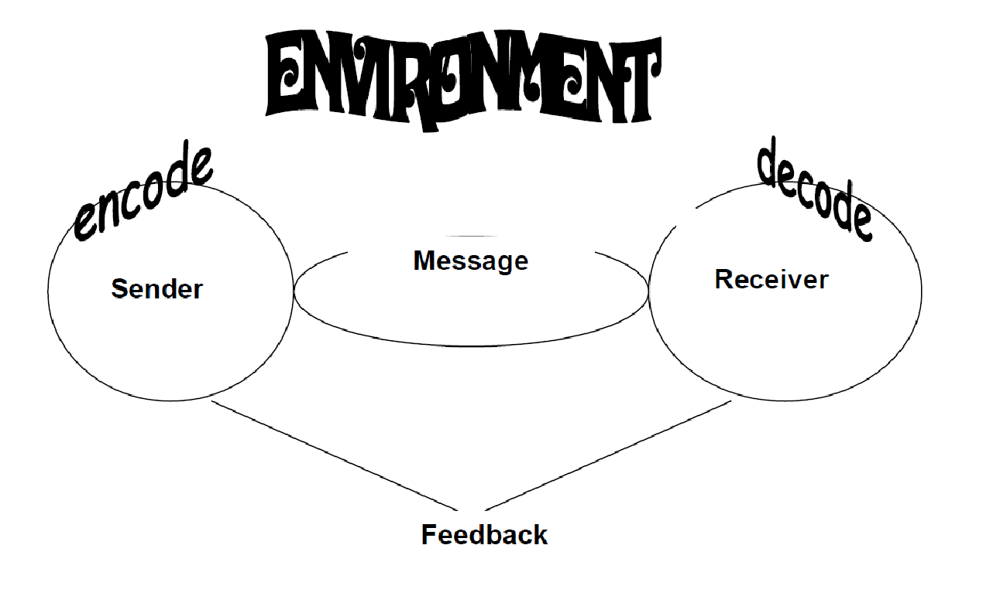
There are many factors which influence the communication process, all of which impact
each other in a variety of ways.

♦ Sender - the sender is the speaker/writer. A sender starts with an impulse he or
she wishes to express, and then must encode that idea into symbols (words) and
signs (facial expressions, tone of voice, etc.).

♦ Message - the message is the symbols and signs which are actually transmitted.
All messages are carried by a channel (face-to-face, over the phone, email, letter,
etc.).

♦ Receiver - the receiver is the listener/reader. The receiver must decode the
symbols and signs of the message, sent through the channel. Decoding involves
working through one's own perceptual filters, to arrive at thoughts which
approximate the sender's original intent.

♦ Feedback - feedback is the signs the receiver projects while the sender is sending
the message. Feedback allows the sender to know how his or her message is
being received, and whether the received message is the same as the intended
message.

♦ Environment - environment is the physical, social and emotional influences (often
referred to as 'noise'), the communication takes place in. Environments can place
expectations and/or constraints on communication.
In looking at the above communication model, we must understand that the environment or 'noise' factor plays a larger role when it comes to oral communication. The reason for this, is that a person listening to another person, is far more easily distracted than a person reading something

EXAMPLE
♦ when other people are talking nearby while you are
listening to someone, you often 'eavesdrop' on their
conversation and miss what is being said to you

♦ when music is playing nearby, you often listen to that,
instead of what is being said to you

♦ when you see something interesting/funny/or a person
nearby, you focus on that instead of on what is being
said to you.

We can see from the above that it is vital to focus/pay attention, when wanting to
receive oral information successfully.

- Group dynamics

When people work in groups, there are two quite separate issues involved.

♦ The first is the task and the problems involved in getting the job done. Often this is the only issue which the group considers.
♦ The second is the process of the group work itself: the mechanisms by which the group acts as a unit. If both the task and the process issues are well managed, the worth of the group could be many times the sum of the worth of its individuals.
Therefore, successful group dynamics are just as important as the final presentation.

The following information is designed to help you make the most of group work:

Meetings:

♦ The place for groups to make decisions is in a meeting. Once the group is set up
and assigned a task it should:

♦ have an early first meeting
♦ meet regularly
♦ let everyone have a say

Planning: To divide up a task between a group of people and deliver it to a schedule requires a plan. Planning can be formal or informal - a formal plan makes deadlines and responsibilities clear. For a group work presentation:

♦ make a plan
♦ assign clear responsibilities
♦ set deadlines
♦ monitor progress at the meetings
♦ do fair shares of the work

Group/Individual Tasks: Divide up your project into group and individual tasks. Groups are best at:

♦ generating ideas
♦ making plans
♦ checking and agreeing outputs

Individual work is most suited to:

♦ discussion leader: keeps group on track; maintains full participation
♦ Recorder: records assignments, strategies, unresolved issues, data; convenes
group outside of class
♦ Reporter: reports out during whole class discussion; writes up final draft of
assignments
♦ accuracy coach: checks group understanding; finds resources

Further Points:

♦ keep copies of work (someone else may lose it)
♦ report any insurmountable difficulties to your leader
♦ get the job done on time
Therefore, the main determinants of group effectiveness are:
♦ Equal distribution of work
♦ Efficient management and control of work
♦ Brainstorming - gathering ideas, information and suggestions
♦ Ground rules - e.g. - come to class on time everyday

⇒ come to class prepared/with work completed
⇒ notify group in event of absence
⇒ be willing to share information
⇒ respect the views, values and ideas of other members of the group

♦ Resolution of disagreements
INTERPRETATION

Groups are like relationships - you have to work at them.
The individual's talents are better utilized in a group.
Dynamic areas where oral communication takes place

Interviews

Companies do not interview every job applicant, they pre-screen. If you do not meet the preliminary qualifications, you are not interviewed. Some jobs that require interviews:

♦ jobs working with the public
♦ jobs answering telephones
♦ jobs where special skills are needed (accounting, finance, banking)
Some jobs that would not require interviews:
♦ digging ditches
♦ pruning trees
♦ digging graves

In order for an interview to flow smoothly, it has to be carefully planned:

The venue: The venue should be quiet (away from traffic and other noise, especially people who could cause a distraction) and comfortable (chairs should be soft and comfortable and there should be something pleasant to look at e.g. flowers or a good painting). This is the ideal situation, but in reality it often cannot happen. It is then that the interviewer has to be flexible and make do with the given circumstances. A good interviewer will be able to conduct a successful interview, irrespective of the circumstances!

Background research: It is generally accepted that the more interviewee data can be gathered before the interview, the more reliable and easier the interview will be. Prepare for the interview by reviewing the application, resume (CV), test results and other materials submitted by the candidate. It is also imperative that the interviewer has extensive knowledge about the environment, its people and their jobs. He needs to know what is happening and what could happen in future.

Thorough research about the interviewee serves three purposes:

♦ because the interviewer knows all the 'superficial' facts, he can focus on underlying problems, without having to do additional research
♦ the interviewer does not waste time with unnecessary questions
♦ it supplies guidelines as to the types of questions that need to be asked

The interview: A structured interview will prevent confusion and repetition on the side of the interviewee as well as the interviewer. It is, however, necessary to be flexible, depending on the circumstances. The amount of structure will be determined by the type of interview. Questions need to be planned and ordered in a meaningful way. Put the interviewee at ease and ask interview questions that cannot be answered with a "yes" or a "no" response. Open-ended questions allow interviewees to tell about their skills, knowledge and abilities.

EXAMPLE
e.g. "Why are you leaving your current employer?"
"Do you prefer routine, consistent work, or fast-paced tasks
that change daily?" "And why?"

Final preparation: The interviewer must prepare himself mentally and block out any thoughts that are not relevant to the interview. He must make sure that he is not biased and that he will assess the interviewee on their merits. Background research, the interview and final preparation should assure that the conclusions drawn are correct and fair.

- Developing questions

Descriptive:
♦ does something need to be described? E.g. "How do
♦ graduates of the XYZ program for the unemployed
♦ seek out and find jobs in the community?"

Normative:
♦ does something need to be compared? E.g. "How well
♦ does the program meet its goals for placing graduates in jobs?"
Impact: (cause + effect)
♦ has something made a difference? E.g. "Why do some graduates find jobs and
others do
There are different ways of asking the same thing : not find jobs?"

EXAMPLE
To determine age:
♦ "How old were you on your last birthday?" OR
♦ "On what day, month and year were you born?"
Both questions help you determine the individual's age, but
the second question elicits much more information.

7. Interview problems to avoid
♦ Be familiar with topics that aren't permissible as interview questions.
EXAMPLE
don't ask a female applicant detailed questions about her
husband /children and family plans.
It could be used as proof of sex-discrimination if a male
applicant is selected.

♦ Avoid making statements during the interview process that could be alleged to
create a contract of employment

EXAMPLE
terms like "permanent", "career job opportunity" or "long

term".
♦ Avoid making excessive assurances about job security unless the employer can
prove that he did not do a good job.

EXAMPLE
the applicant is told "if you do a good job, there's no reason
why you can't work here for the rest of your career". The
applicant accepts the job and six months later is laid off due
to personnel cutbacks, which he refuses to accept,

8. Disciplinary interview structure

Disciplinary and grievance interviews occur when either the employer or the employee has a cause for complaint against the other. They take place in a quasi-legal framework according to internally documented procedures designed to comply with legislation.

8.1 Rules for the interviewing manager conducting a disciplinary interview

♦ must be very clear about the reasons for the interview
♦ must articulate the reasons to the employee
♦ must ensure that investigations are conducted as quickly as possible
♦ must give clear and unambiguous warnings (verbal or written)
♦ must state clearly what the employee is expected to do to rectify the
♦ situation
♦ must follow the internal procedure
♦ must keep records of the interview and any actions arising

8.2 Structure

Opening:
♦ Tone: the interviewer should be in control of the interview at all times.
Discussion:
♦ Explaining: explain clearly the reasons for this interview, nature of complaint and
company policy; refer to company procedures.
♦ Listening: allow the employee to tell his/her version of the facts or to offer
mitigating circumstances.
♦ Outlining: explain what will happen next, the exact nature of warning the warning
you are giving and the consequences.
Conclusion:
♦ Agree: ensure that the employee has understood the understanding warning, the
implications and what he/she has to do next.
♦ close out: terminate the interview and record it according to procedures

9. Formal meetings

It is important to remember that matters discussed at a meeting can only be legally
effective and binding if the following legal requirements have been met:

♦ the meeting must be properly convened. Notices must reach the members in accordance with the constitution of the organization.
♦ the meeting must be properly constituted. The right person must be in the chair, and there must be a quorum; in other words, the minimum number of members entitled to vote, must be present.

All types of meetings are subject to:

♦ the country's laws or statutes
♦ the organization’s constitution
♦ the common law
♦ the organization’s own customs and practices

Formal meetings are made up of private meetings and public meetings.

9.1 Private meetings
Only members are entitled to be present at private meetings. Sometimes an outsider is allowed to attend such a meeting as an observer, but he does not have the right to vote.

EXAMPLE
The following organizations, for example, hold private meetings:
♦ Companies with limited liability
♦ Bodies such as church, school or city councils
♦ Bodies such as private clubs or associations

9.2 Public meetings

These include the following:

♦ Conferences
♦ Symposiums
♦ Seminars
♦ political meetings
♦ national meetings

Such meetings are advertised in the media or by mail, and are attended by the public at large. The conveners usually appoint the chairman and the meeting then proceeds according to its usual custom.

10. Structure of a formal meeting

Booking the venue:

Book the venue well in advance, keeping in mind the requirements of the meeting.

EXAMPLE
e.g. number of people attending, equipment used for
presentations, etc.

Preparation:
simplify your arrangements as much as possible, by getting the logistics
right
EXAMPLE
, e.g. tables and chairs, lighting, stationery, name
badges/stickers, programs/agendas, water jugs and glasses.

Notice of a meeting: The timing and the form required is very important. Don't send the notices out too early, people forget easily and the notices may lose their effectiveness

Agenda: The agenda is a list of matters to be discussed at a meeting in a specific order.

The chairman may only change the order with the meeting's consent. Notes: Jot down only the most important points. Make a note of all the changes to the minutes.

The minutes: These are a report of the decisions made at the meeting. They are the official historical record of an organization.



10. Discussions, debates or negotiations
10.1 Discussion
A discussion is to have a conversation about, or consider by talking over, a specific topic/s.

Here are 10 discussion techniques:

1. asking someone for their opinion about a topic
2. delaying strategies
3. presenting a number of arguments
4. giving your opinion about a topic
5. agreeing - completely or conditionally
6. disagreeing
7. countering
8. logical argument
9. clarification
10. expressing solutions and alternatives

Discussions can be formal or informal and can play a very important part in the communication in an organization.

10.2 Debate
A debate is a formal discussion in which opposing arguments are put forward. It includes persuasion, which appeals to the emotional responses of an audience. The outcome of a debate may be decided by audience vote, by judges, or by some combination of the two.

A debate can be informal or formal.
Informal debate has a number of advantages:

♦ Debating reflects the learning process. Debate establishes extremes, allowing the
viewers and participants to see the areas in between more clearly.
♦ Debating allows students to explore ideas and arguments in a non-threatening
atmosphere, because presentational guidelines are provided.
♦ Debating is an effective method of acquiring knowledge, as arguments need to be
supported by relevant, accurate, and complete information.
♦ Students who debate informally learn to recognize the elements of a good argument and to develop further their abilities to speak confidently

11. Structure of a formal debate:

A debate is about a topic, usually called the moot. The moot is a claim that something is true.

That South Africa needs a well-equipped air force
♦ That the school system benefits all students who
choose to work hard.
♦ That space exploration is a waste of time.
♦ That New Zealand's population is too small.

There are two teams with three speakers each. One team agrees with the moot (the Affirmative) and the other team disagrees (the Negative). Usually you are given the topic and told whether your team is affirmative or negative. This means you may be debating a position you personally don't agree with. This is the skill of debating, and it helps you understand that there are two sides to most questions.

11.1 Affirmative and Negative

Each team divides up the job of researching the evidence and preparing the case. Each team member writes speech notes. The first people to speak use their notes more, while the later speakers will be answering what their opponents have said (rebuttal).
1. | Affirmative leader | Define moot, introduction
2. | Negative leader | Define moot, introduction
3. | Affirmative second speaker | Further arguments
4. | Negative second speaker | Further arguments
5. | Affirmative third speaker | Mostly rebuttal
6. | Negative third speaker | Mostly rebuttal
7. | Negative leader | Summary (no new arguments)
8. | Affirmative leader | Summary (no new arguments)

Purpose

What is the point of the debate? Each team is trying to win by doing the best job of arguing their case. This does not mean that one team must be right and the other one wrong. There are two sides to any debate, and either side could win.

12. Negotiations

Broadly speaking, negotiation is an interaction of influences. Such interactions, for example, include the process of resolving disputes, agreeing upon courses of action, bargaining for individual or collective advantage, or crafting outcomes to satisfy various interests. Negotiation is thus a form of alternative dispute resolution. Negotiation involves three basic elements: process, behavior and substance. The process refers to how the parties negotiate: the context of the negotiations, the parties to the negotiations, the tactics used by the parties, and the sequence and stages in which all of these play out. Behavior refers to the relationships among these parties, the communication between them and the styles they adopt. The substance refers to what the parties negotiate over: the agenda, the issues (positions and - more helpfully - interests), the options, and the agreement(s) reached at the end.

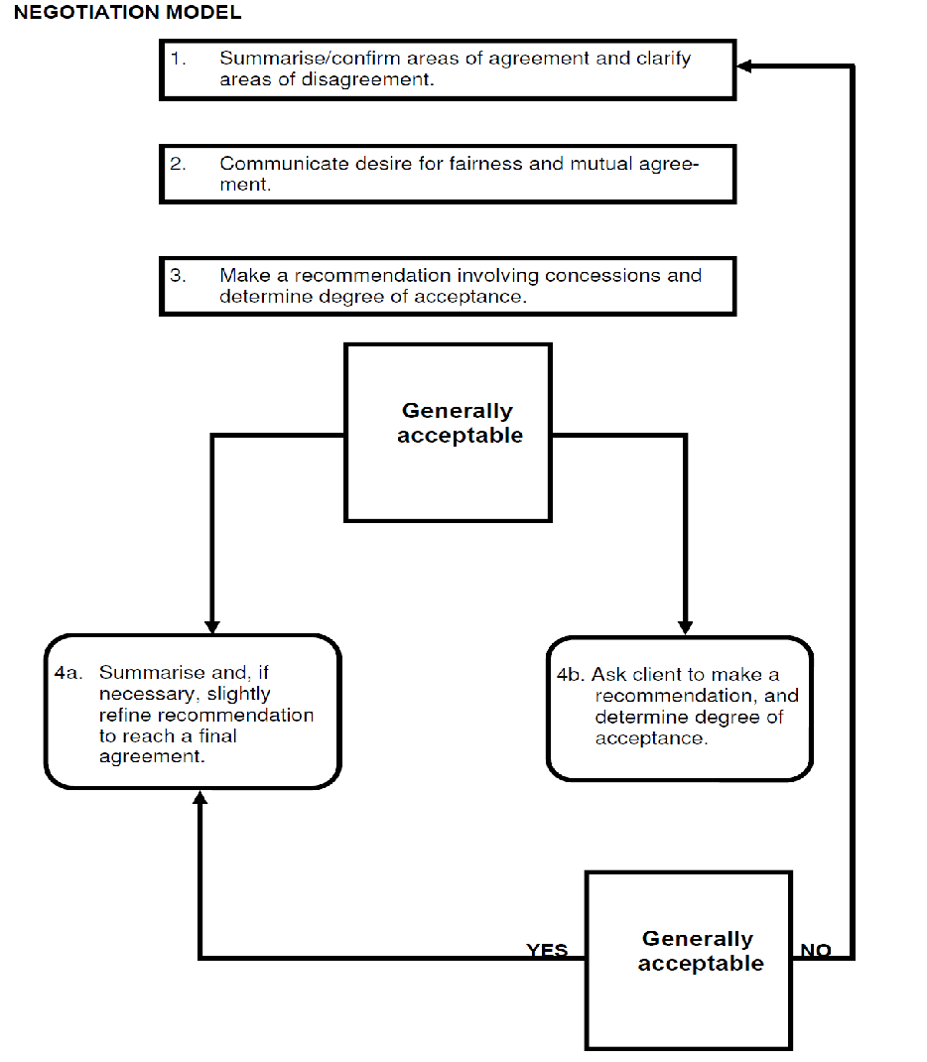
As can be seen from the model on the previous page, these three communication tools (discussion, debate and negotiation) are of great importance in an organization, and their use will be determined by the topic and the circumstances/situation.

Register reflects the situation and determines the most appropriate language. Socio-cultural sensitivities must be kept in mind, so that offensive language is not used. Own values or arguments must, however, not be compromised in doing so.

SESSION 2.

USE STRATEGIES THAT CAPTURE AND RETAIN THE INTEREST OF AN AUDIENCE.

Learning Outcomes
- Key words/signs, pace and pause, stress, volume and intonation or sign size, pace, rhythm and non-manual features (NMFs) are used in appropriate ways to reinforce the message.
- Body language is appropriate to context and topic, and reinforces main ideas and points of view.
- Formal communications are planned in writing/signing, and plans are detailed, complete, and realistic with respect to time allocation and content.
- Visual aids are appropriate to topic and context, and enhance the presentation and the transfer of information and understanding.
- Techniques are used to maintain continuity and interaction.

- Strategies that capture and retain the interest of an audience

The material of your presentation should be concise, to the point and tell an interesting story. In addition to the obvious things like content and visual aids, the following are just as important, as the audience will be subconsciously taking them in:

Your voice: How you say it is as important as what you say. Throughout your presentation, try to convey your enthusiasm and belief in the topic. The use of your voice establishes……

♦ rapport,
♦ maintains interest,
♦ emphasizes points and assists comprehension of the information by the audience.

This can be achieved by THE FOLLOWING:

♦ varying volume,
♦ pace,
♦ pitch,
♦ pause and
♦ tone.


Talk at a moderate pace if you have
excellent content. If your arguments are
weak, speak at a faster pace as this will
give people less chance for developing
counter arguments. Fast talkers are
regarded as more competent, truthful,
fluent, energetic, enthusiastic and
persuasive. By talking fast, you move
the attention from the content to
yourself. This being said, it is important
to match your pace to what needs to be
said - important instructions or
explanations need to be presented at a
moderate pace, whilst general
information could be presented at a faster pace.

Use a quiet, reasonable tone for the content, but still show some energy and interest. Pauses of two seconds before key points are recommended to create interest and attention in what follows. Pauses after key points allow people to reflect on what was said.

Body language: Your body movements express what your attitudes and thoughts really
are. Your movements attract attention and give the audience something to follow. The following tips can assist you.

♦ If you have been standing still or behind a podium, move to the right or left or toward the audience.
♦ Use gestures to emphasize a point.
♦ Facial expressions also help to convey a message.
♦ Maintain eye contact and don't forget to smile!
Different body posture
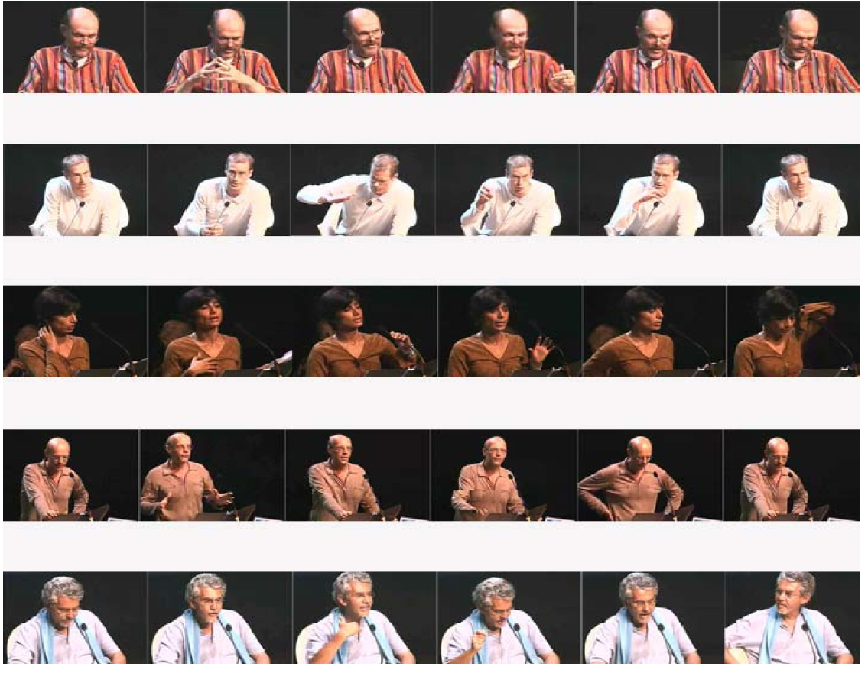

Appearance: First impressions influence the audience's attitudes to you. Dress appropriately for the occasion and to show you respect the audience
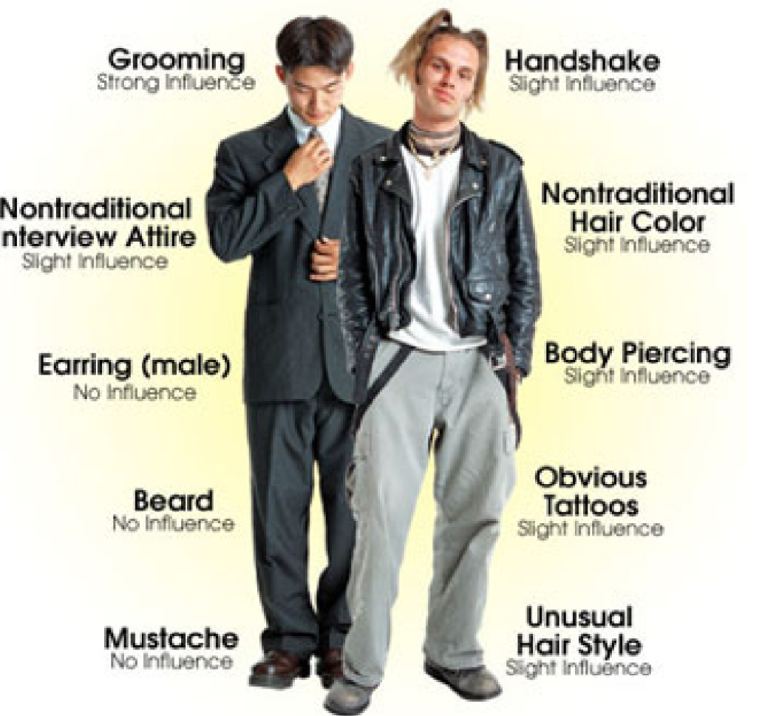
As with most personal skills, oral communication cannot be taught. So as always, practice is essential, both to improve your skills generally and also to make the best of each individual or group presentation you make.

- Planning

Initial Planning: This is where you begin to tailor the talk to the situation, and for that reason, this stage is very important for a successful presentation. Begin this stage early, the more lead time you allow yourself, the more time you will have to think up potential approaches to the topic and the more interesting and substantial your presentation will be.
Before you begin preparing the presentation, you'll need to determine:

The type of talk you'll be expected to give:
♦ Will this be an informal chat, a seminar discussion, or a more formal presentation?
♦ Different talks have different purposes.
The composition of the audience
♦ Will you be speaking to a general audience or specialists?
♦ How many people are expected to attend?
The time allotted for the talk
♦ The longer the talk, the more freedom you will have to explore the topic.
♦ A short talk needs to be very clear and to address the topic directly.
♦ Let your audience know that you regard their time as precious and have no intention
of wasting it.
♦ Keep to your allotted time - do not extend it and do not keep rambling on just to fill
your time slot. "If you haven't struck oil in five minutes - stop boring!"

Expectations for information content
♦ What is the purpose of your talk? Clarify the expectations beforehand and plan to
address them during the presentation.
♦ Will you be presenting novel concepts to this audience, or building upon their prior
knowledge? Either way, make sure you cover the basics clearly, and early in the talk, to avoid confusing the audience.
3. Visual aids
Visual aids enhance the presentation, the transfer of information and the understanding thereof. They do, however, have to be appropriate to the topic and the context.

Cue cards: These are a visual aid for you, the presenter. The notes must be written boldly, in print not script, and must list key words only. The cards must fit in the palm of your hand.
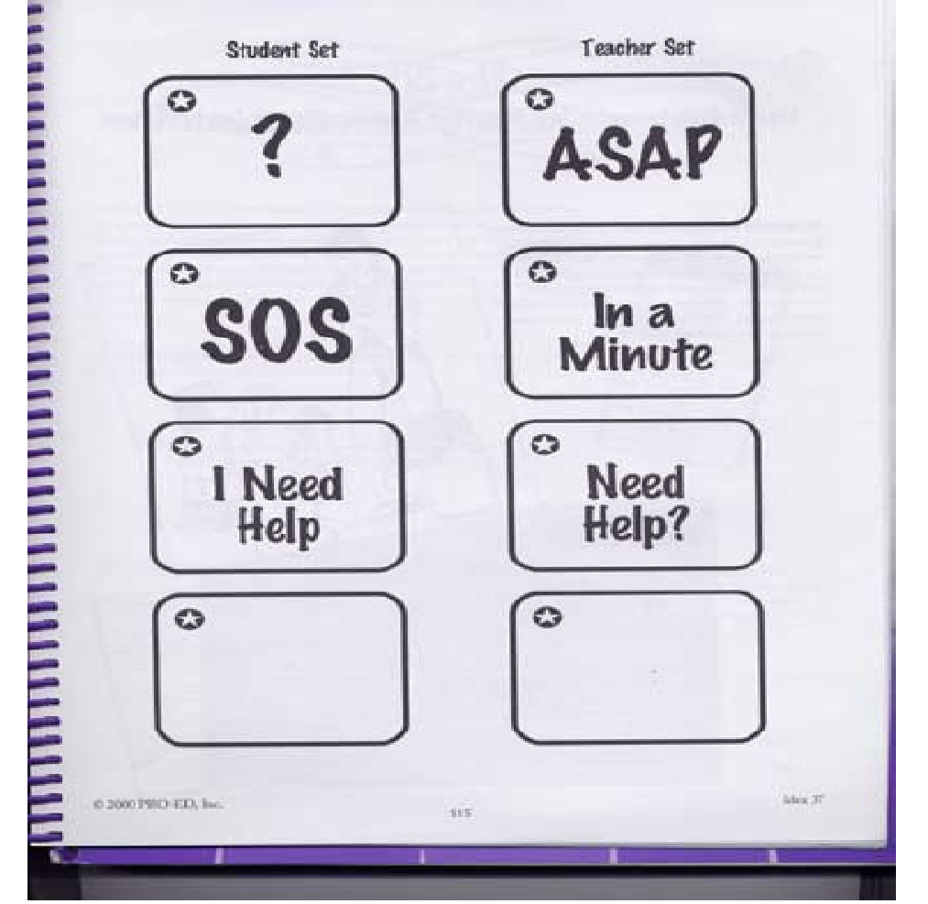

Handouts: Do not hand out material to read when you begin thepresentation:
♦ It may cause the listeners to get
out of step with the speaker,

unless the handout contains
information that needs to be
referred to during the
presentation.
The purpose of this material is to:
♦ Convey information more
clearly and concisely than can
be transferred orally.

Do not include anything that is unnecessary. All tables, charts, graphs, maps and diagrams should be made simple and as clear as possible. Too much detail will make them difficult to understand.

It is a good idea to include your references on a handout, so that people can follow up on them later. A paper record (handout) tells your audience that you are serious, responsible, exact and credible. It gives the audience something they can read, take away, make copies of and refer to at a later stage.

Multi-media and visual aids: PowerPoint presentations, transparencies, or flip charts can help people follow the talk. This is especially important to show organization, present lists, highlight illustrations and exhibits, and summarize data. People think in pictures. Say Nike and people "see" the swoosh. Say Energizer and people "see" the bunny. Say (your name hear) and what do people see? That is why logos and other graphical elements are so important. Tapping into the visualization part of the brain is probably the most powerful way to communicate with anyone. When putting together a PowerPoint presentation, keep the following in mind:

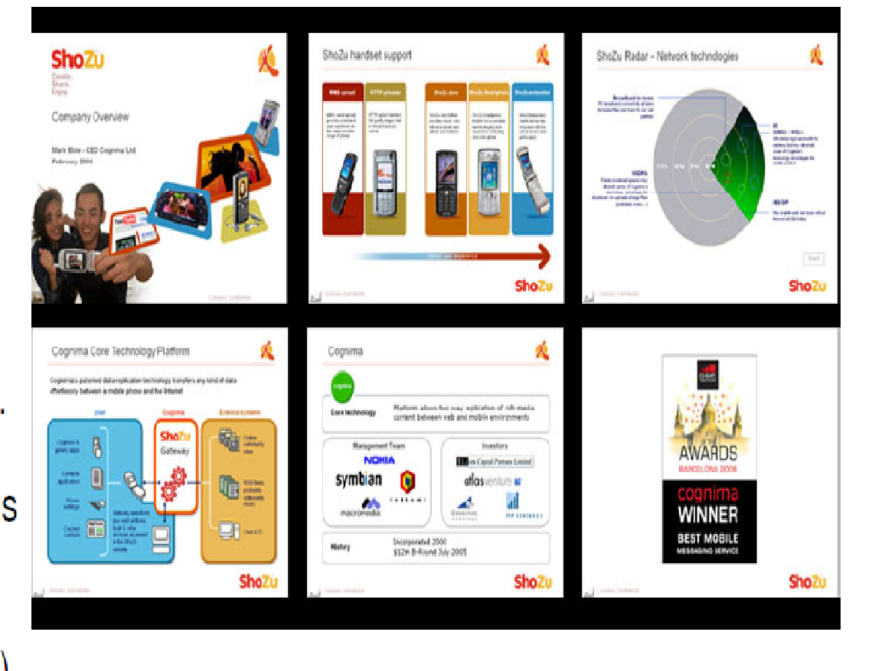
♦ key words on bullet points -
this helps to retain audience
attention and gives you a
reason for being there
(anyone can read, so you do
not want to read to them).
♦ omit anything that is not vital. PowerPoint often leads people to include irrelevant things (only if you have nothing
important to say, should you
use lots of bells and whistles).

♦ only use colour when the colour has a meaning. Keep in mind that some people are colour-blind and others may make black and white copies of the slides, in which case the colour would be meaningless

- Continuity and interaction

Continuity and interaction are vital for a successful presentation. It is imperative that the speaker/presenter be very well prepared. This will ensure a smooth presentation and good timing. It will allow the speaker to pick up on any confused or perplexed listeners, as well as check understanding by asking questions. If questions and answers follow your presentation,

Remember to always repeat the question for the entire audience.

Then look at the questioner when answering. If you are unsure, don't make up an answer, rather say you don't know and say you need to get back to them

SESSION 3.

IDENTIFY AND RESPOND TO MANIPULATIVE USE OF LANGUAGE.

Learning Outcomes
- Facts and opinions are identified and distinguished.
- Omission of necessary information is noted and addressed.
- The implications of how the choice of language structures and features, specifically tone, register, style and point of view affect audience interpretations of spoken/signed texts are explained
- Distortion of a contributor's position on a given issue is explored with specific reference to what has been selected and omitted.

Identify and respond to manipulative use of language

Humans all over the world tend to be manipulative beings. They achieve this through acts, but mostly through their choice of words.

To manipulate means to control or influence something or someone cleverly, deviously or skillfully, often for one's own advantage.

A person can say the same sentence twice, but using a different body language or tone of voice the second time, and the listener/receiver of the message will receive two very different messages. E.g. "sit down" said in a gentle, kind manner, would make a person feel comfortable and nurtured, while "sit down!" shouted in an unfriendly way, would make a person feel nervous and expect trouble.

In the same way, a person can manipulate others by 'confusing' facts and opinions, by selective omission of necessary information and by subtly forcing their own point of view onto them.

In order to avoid the above, one needs to be able to identify and distinguish facts and opinions.

Fact: A statement of actuality or occurrence. A fact is based on direct evidence, actual experience, or observation. A fact is a statement that can be proven true
Opinion: A statement of belief or feeling. An opinion expresses someone's belief, feeling, view, idea, or judgment about something or someone.

2. Guidelines to help keep fact and opinion apart
Opinion … | Fact …
♦ does the author/speaker use words  that interpret or label, such as:  pretty; ugly; safe; dangerous; evil;  attractive; well-dressed; good; and  so on?  ♦ are there words that clue you to  statements of opinion such as:  probably; perhaps; usually; often;  sometimes; on occasion; I believe; I  think; in my opinion; I feel; I suggest;  and so on?  ♦ can you identify differing opinions  and their effect on the author's/  speaker's views?  ♦ does the truth of the premise  depend on us accepting a certain  definition of key words or concepts?  Has the author/speaker defined the  conditions for using the concepts? | ♦ can the fact be verified by direct  observation?  ♦ can the facts be trusted? How did the  author/speaker come to the facts?  ♦ does the author/speaker have the skill  and experience to make such a  statement?  ♦ are the facts presented in an objective  manner? (any bias evident or  suspected?)  ♦ does the author/speaker make clear the  sources of statements from authorities?  Are these authorities reliable?  ♦ can the study which generates the facts  be duplicated?  ♦ are the facts relevant to the point being  made?  ♦ have unfavorable or negative points been  left out? (are there counter-studies?)  ♦ do the facts prove the claim being made  or do they merely suggest that the claim  is reasonable?

Remember that your acceptance of an author's/speaker's opinion or claim depends on your own view of the subject and of the writer's/speaker's work. To help evaluate an author's/speaker's ideas, you need a clear understanding of your own opinions.

EXAMPLE
"Registration and control of firearms in Canada is not supported by the Canadian public, and will not lead to a decrease in gun-related crime" The underlined statement is a fact. The statement in italics is an opinion.

There is nothing wrong with mixing opinions and fact together in an argument. What is important is that the reader be able to distinguish the fact from the opinion, in order to make a sound judgment about the information they are receiving.

3. Omission

Just as opinions disguised as facts can mislead and manipulate readers/listeners, the omission of important/necessary information can do the same. A classic example of the consequences of omission, is when getting a recipe from someone! How often does a person not really want to share their culinary secrets with you, but is obliged to do so. In order for their dish/end product still to be the best, they leave out a specific ingredient, or a specific part of the method, which is vital to the success of the recipe.

Another example, which can have far reaching consequences and occurs regularly in the workplace, is when a subordinate becomes a threat to his/her superior. It is the superior's duty to lead by example and also to teach/assist the subordinate when necessary. As soon as the superior realizes his/her position is in danger, he/she omits necessary information, which then makes the subordinate look bad when things go wrong that he/ she has done. If management does not pick up on this, it buys the superior time and sometimes favour.

Often people do not realize that necessary information has been omitted, because they do not have sufficient knowledge about the topic. In order to try and avoid this, it is necessary to get confirmation that your understanding is correct. It is also advisable to be aware of any negative attitudes that might be present.

When attending a talk or presentation, it is difficult to judge whether necessary information is being omitted. It is therefore necessary to check the reliability of the information by discussing it with other audience members - often some of them have sufficient knowledge on the topic.

- Choice of language structures

One of the easiest ways to manipulate people is by the choice of language structures and features, such as tone, register, style and point of view. These have been looked at before, but need to be recapped.

♦ Register reflects the situation and determines the most appropriate language. Socio -cultural sensitivities must be kept in mind, so that offensive language is not used. Own values or arguments must, however, not be compromised in doing so.

♦ Style is the manner in which a writer addresses a matter, a manner which reveals
the writer's personality, or 'voice'.

♦ Tone is the sound of your voice, with reference to quality, pitch and volume.
♦ Point of view is your mental viewpoint or attitude.

Listen for tone, attitude, and clarity. Is the tone you project appropriate for your audience and your purpose? Is each sentence easy to understand? Are you speaking too rapidly? Are the major divisions in your presentation easy to hear? Are any sentences difficult to understand?

By looking at the above, it is easy to see how it can be used to manipulate an audience - positively or negatively.

The best examples of manipulation using language, are found in the advertising world and political speeches.

As soon as you read this, you think free calls! Whether you intended phoning someone or not, you start thinking of the possibilities, because you might not need airtime to do so. You have been manipulated! You are doing exactly what Vodacom wanted you to do, i.e. think about phoning someone.

The rest of the advertisement reads as follows:

"Introducing Vodacom Reverse Charge. Simply dial 082 180 + the full number of the person you need to reach. Now all Vodacom contract customers can accept call charges from any Vodacom customer."

By reading the rest of the advertisement, you realize that you cannot phone for free - someone is still going to pay for it, even if it is not you. Vodacom did not lie to you by promising free talk time, they just manipulated you with their choice of words.

EXAMPLE

Live in the spirit of Africa. Africa. The Serengeti - a place where your spirit can soar above endless, rolling grasslands."

Add to this a beautiful picture of a sunset over a plain with the silhouette of just one thorn tree, and you are transported to another world, free of stress and problems. Just the place most people would like to be!

The beginning of this advertisement has already manipulated your thoughts. You think of your present situation and often become disillusioned with it, or you start planning for something that you would love, but can't really afford.

On reading the rest of the advertisement, you find a wonderful lifestyle that is out of reach for most of the population:

EXAMPLE
"This is what you'll find once you secure a lifestyle at Serengeti Golf and Wildlife Estate. Within this 780ha estate you will not only find peace and tranquility, but also a range of facilities for the whole family to enjoy: …"

These are two examples where nothing wrong or dishonest has been done, but by clever use of language, have managed to manipulate the reader into thinking of previously insignificant things.

The following extracts are from remarks by President George W Bush to teachers and students at Townsend Elementary School in Townsend, Tennessee, on 21 February 2001.

Manipulative use of language
"Yesterday I also outlined some funding priorities of mine. I'm going to submit a budget next week to the United States Congress -- it's a budget that sets clear priorities. A priority is going to be to make sure that our Social Security system and the payroll taxes are saved for Social Security and the Social Security system is strong. A priority would be Medicare. A priority is going to be to make sure our troops are well-paid and well-housed and well-trained, so that we can keep the peace. A priority is going to be pay down debt. A priority is going to be tax relief, so hardworking Americans have got more money in their pocket to pay down their own debt and to cover the cost of high energy costs."

We can see in the first extract that President Bush was telling the teachers and students
what they wanted to hear. His style and register was appropriate to his audience, which
would most likely ensure their support for him.

In the second extract he spreads his manipulation even wider, to include the rest of the
population. He addresses the Social Security System, which provides for the poor; he
addresses salaries, housing and training for the troops; he addresses tax relief - which
will affect the whole population. By his clever use of language, he manages to win the
support of millions of people.
In the following extract from 'Distortion of Fact' by Andrew Burfield, we can see how the omission of vital information can distort the whole picture. The Commission had reported that there were nineteen hijackers, all of whom had died in the attack.
To distort means to alter or misinterpret facts, or to twist or pull out of shape.

EXAMPLE

"The omission of evidence that at least six of the alleged hijackers — including Waleed al-Shehri, said by the Commission probably to have stabbed a flight attendant on Flight 11 before it crashed into the North Tower of the WTC — are still alive."

The above extract clearly illustrates how the credibility of "the Commission" is affected and the whole picture distorted, by the omission of credible reports that provide the necessary proof that those people are still alive.

GLOSSARY OF TERMS (Educational terms)
WORDS//ACRONYMS | EXPLANATIION OF ACRONYMS
ASSESSMENT | “A structured process of gathering evidence and making judgments about  an individual’s performance in relation to registered national standards and  qualifications”
ASSESSMENT CRITERIA | It describe the evidence that is needed to show that the learner has demonstrated  the outcome correctly.  A list of evidence to be supplied by the candidate as proof of his / her ability  to integrate all of the competencies listed earlier in the standard.
COMPETENCE | Competence is the ability to do certain things in a range of different environments  with knowledge and understanding about what is being done and  the effect this has on others. It includes Knowledge, skills, attitudes, values  and ethics.
CREDIT | Each unit standard is worth a number of credits which gives an indication of  the size and scope of the unit standard, the standard is worth. (1 credit =  10 notional hours of learning
CRITICAL CROSSFIELD  OUTCOMES | critical cross field outcomes is to direct educational activities towards development  of the learners within a social and economic environment.
EMBEDDED KNOWLEDGE | Body of theory essential for understanding and applying the standard.  Principles, methods and techniques that would underpin good practice of  this unit standard.
EVIDENCE | Evidence is a set of information or observations that provides proof of the  learner’s competence.
FORMATIVE ASSESSMENT | Aims to assist the learner to identify any knowledge/skills gaps when demonstrating  his/her current competence. Diagnostic assessment supports  learning and progress of the learner.
INTEGRATED ASSESSMENT | Integrated assessment refers to:  • assessing a number of outcomes together  • assessing a number of assessment criteria together  • assessing a number of unit standards together  • using a combination of assessment methods and instruments for an  outcome/s  • collecting naturally occurring evidence in the workplace  • Acquiring evidence from other sources such as supervisor’s reports,  testimonials, portfolio of work previously done, logbooks, journals  etc.
LEARNING ASSUMED TO  BE IN PLACE | Building blocks (knowledge, skill and understanding) assumed to be in  place
LEARNING PROGRAM | A “learning program is a set of learning activities in which the learner will be  involved in working towards the achievement of one or more outcomes.
LEVEL | Each unit standard is registered on the NQF at a particular level based on  the complexity of the outcomes and stringency of the standards.
NQF | National Qualifications Framework
RANGE STATEMENTS | The range statements indicate detailed requirements of the assessment  criteria.
RE-ASSESSMENT | • The same method and instrument may be used, but, the task and  materials should be different  • The task and materials should, however, be of the same complexity  and level as the previous ones.  • In case the methods and instruments are changed it must be ensured  that they are appropriate for the outcomes specified.
RPL ASSESSMENT | RPL is a way of recognizing what individuals already know and can do. The  basic premise underlying it is that people, especially mature adults, learn  many things inside and outside the formal structures of education and training  and that irrespective of where, how and when learning was acquired,  subject to assessment, it can be worthy of recognition and credit.
RPL | Recognition of prior learning
SASSETA | Safety & security sector education and training authority.
SAQA | SOUTH AFRICAN QUALIFICATION AUTHORITY
SPECIFIC OUTCOMES | An outcome is a statement that describes the required competency that  must be demonstrated by the learner on successful completion of a training  intervention.  Key performance areas in the standard are given, the focus is not only on  current competence, but also on future competence in this standard.
SUMMATIVE  ASSESSMENT | Assessment used to record the level of competence achieved by a learner  over a period of time, e.g. at the end of a program, term or year.
QUALIFICATIONS | Represent a planned combination of learning outcomes which has a defined  purpose and intended to provide learners with applied competence  and a basis for further learning
UNIT STANDARDS | the “building blocks” of qualifications. All qualifications are plotted on the  National Qualifications Framework (NQF). “A statement of the outcomes  that the learner must achieve to earn credit. Standards are nationally  agreed and internationally comparable.”

